Skyler Judson

Chibuike Chikere-Njoku

River Schenck

**Lab 2 – Impulse Response**

**Experiment**

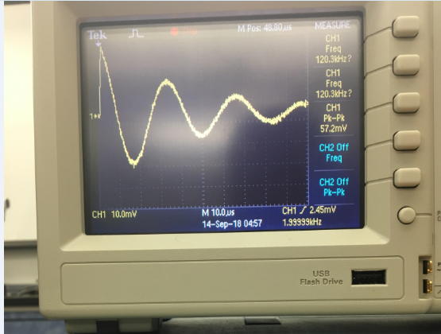

**Matlab Plot**

N = 1000;

t = linspace (0,300E-6,N);

f = 30303.*(-.08737.*exp(-15151.5.*t).*sin(173417.*t) + exp(-15151.5.*t).*cos(173417.*t))

plot (t, f)

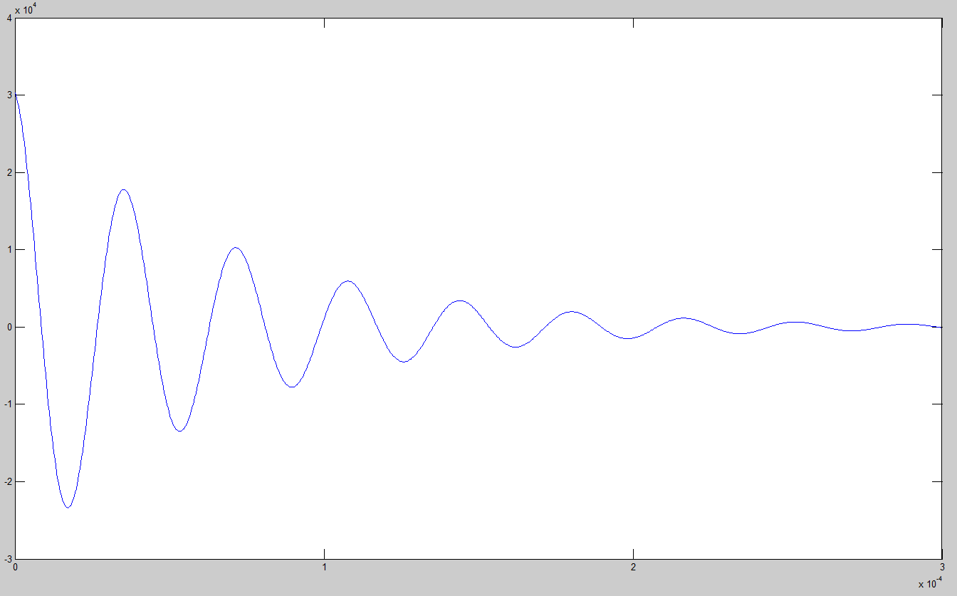

**Calculations**

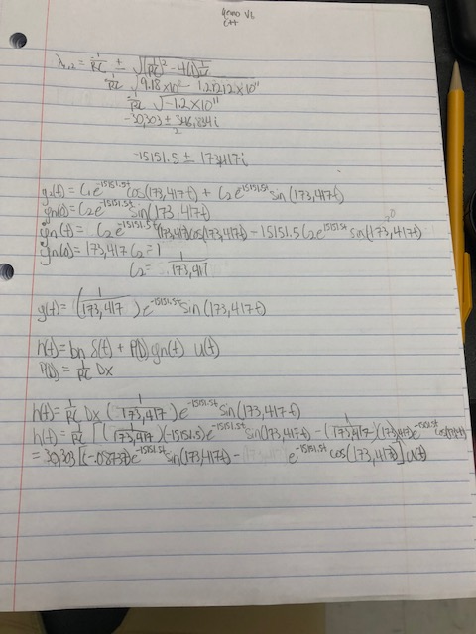

**Conclusion**

Yes it is. The oscilloscope plot is the same as that of the matlab using the impulse response function from calculations. This lab made me feel confident in my ability to calculate impulse reponse.